Task 1 Activity B
Login
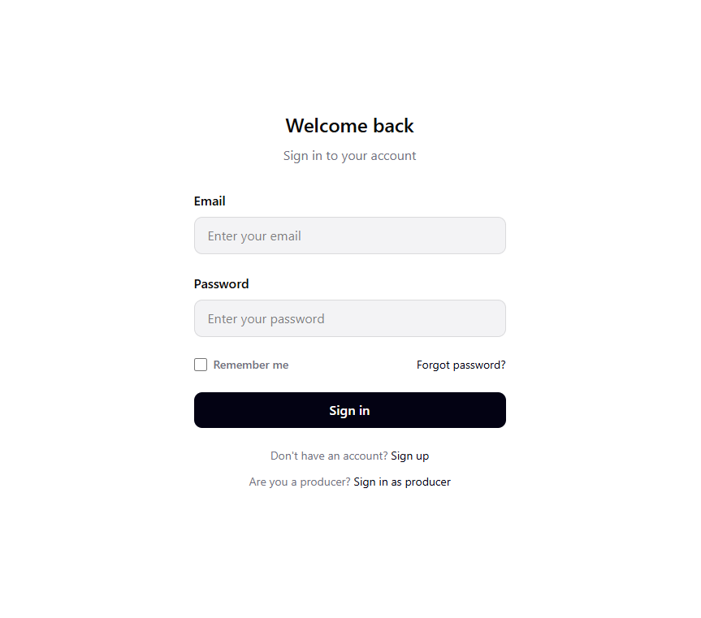
Comments:

Producer Login
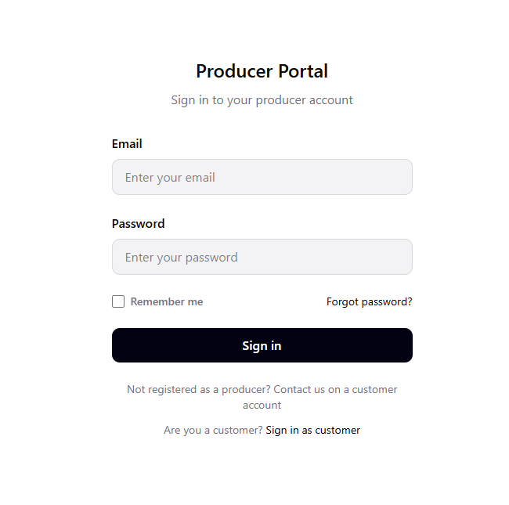
Comments:

Signup
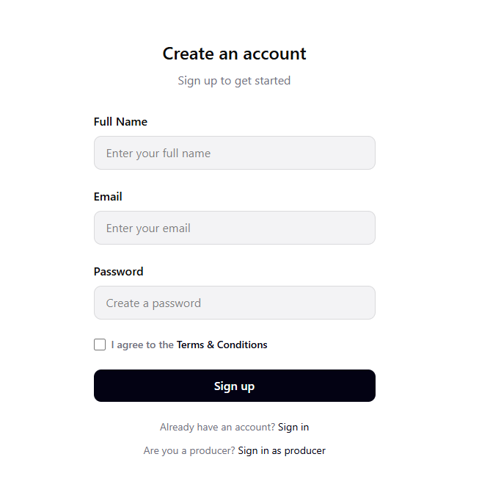
Comments:

Homepage
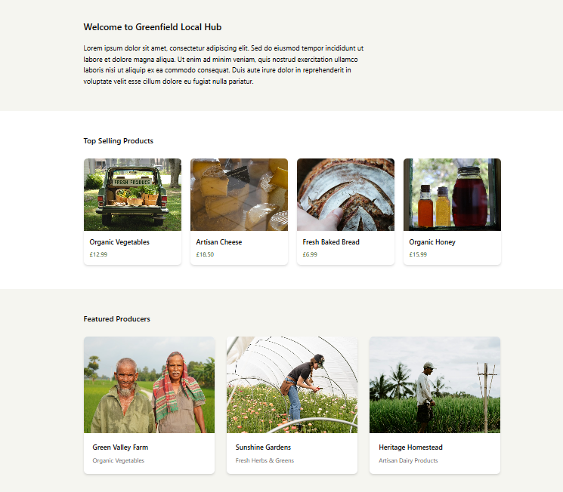
Comments:

Navigation Bar
Comments:

Products Page
Producer Page
Shopping cart
Order Confirmation
Footer
Dashboard

